Below shows relevant code snippets for the forecasting exercise, from defining training/test sets, to our feature validation procedure, hyperparameter tuning, walk-forward testing, and our generation of our reported forecasting results

1. Defining the Training and Test set periods for the 1-day ahead, 7-day ahead, and 14-day ahead forecasting exercises respectively

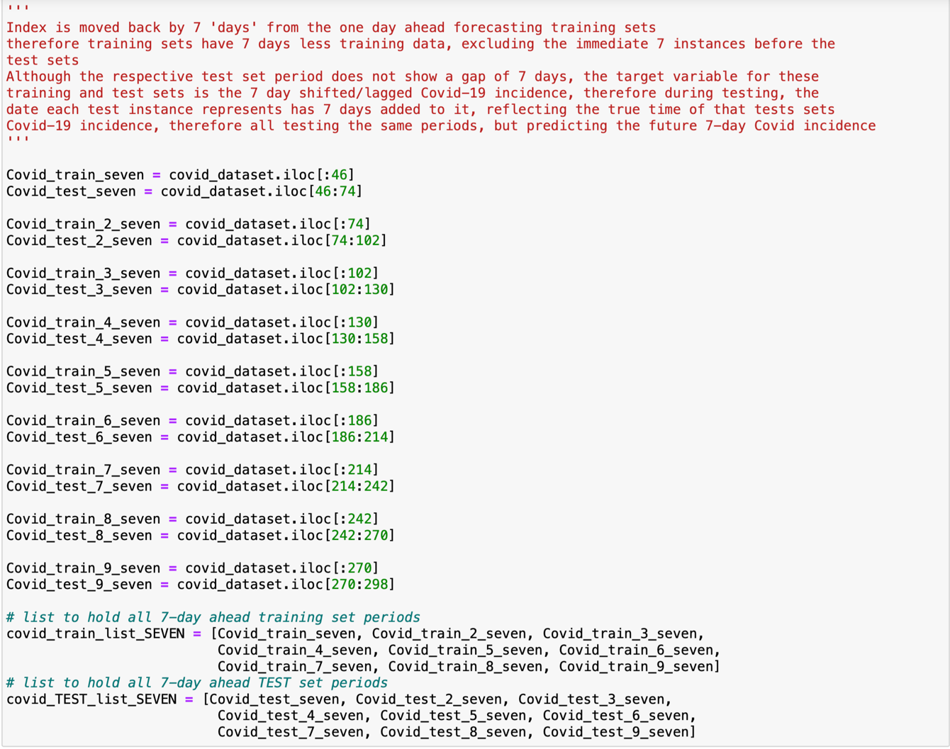

2. Below is how we generate average importance scores for each training set

3. Our ablation studies to identify the optimal feature set

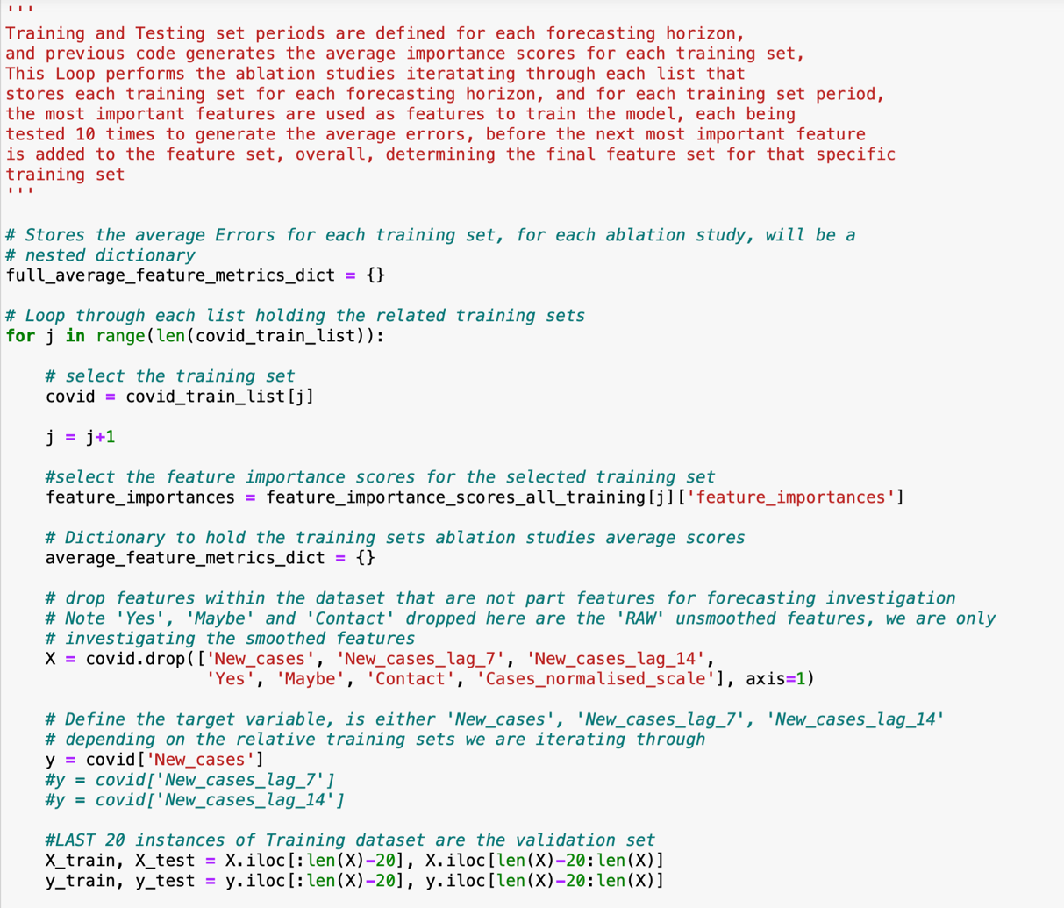



NB: as specified in the methodology – our reddit models must contain at least one reddit feature along with the baseline model to generate our relative comparison against a baseline model, therefore – if ablation studies identify that either no Reddit features of the ‘traditional’ feature does not improve RFR performance for that training period, we still either add the ‘Traditional’ feature, or the most important Reddit feature still.

4. Grid search – for each training test, whether ‘Reddit’ or ‘baseline’ training set

5. Our walk-forward testing approach

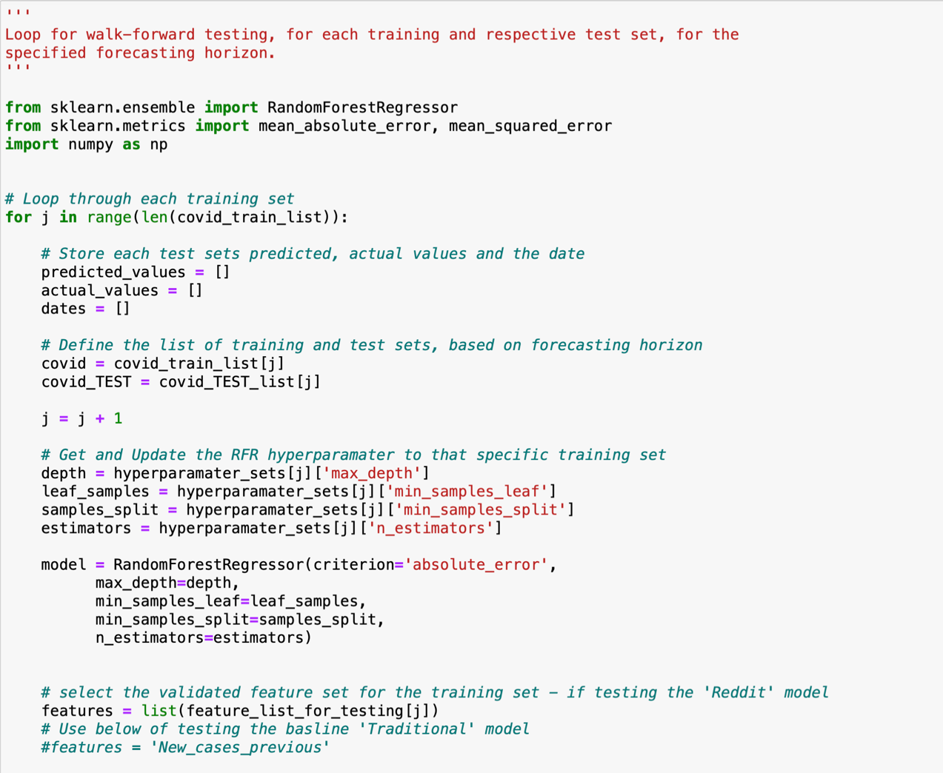

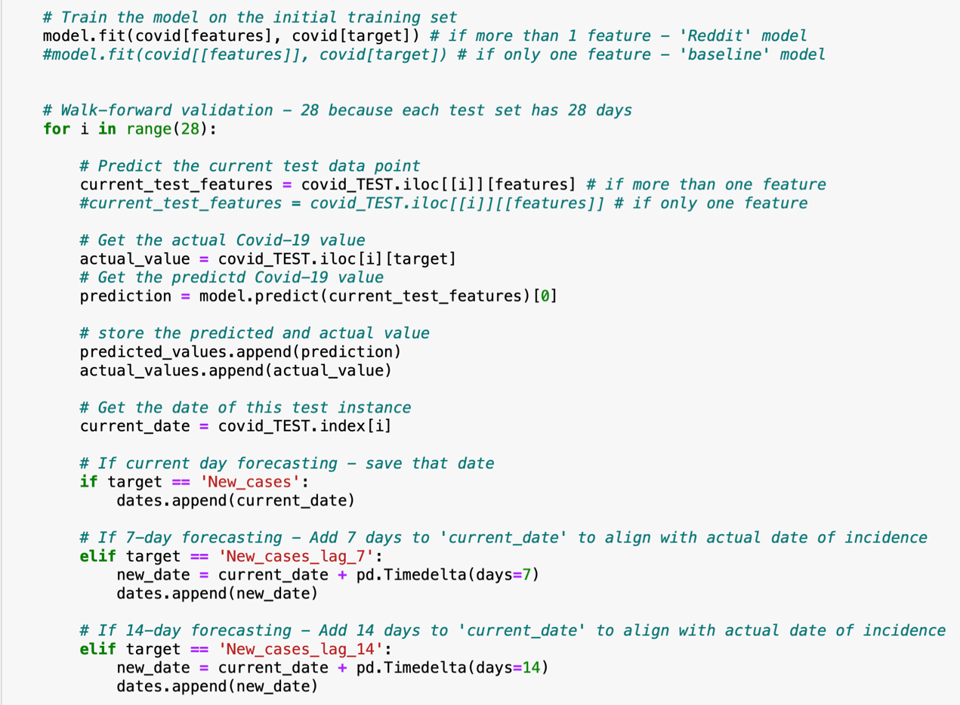

6. How we generate average performance metrics for entire testing period   
- before this – our dataframes are combined to make it suitable for this, so there is only one column for predicted and actual values covering the entire testing period

7. How we generate average performance metrics per testing period



